Go to **File** -> **Open** and click on your image.

Now go to **Layer** -> **New** -> **Layer…**

Take **Brush Tool (B)** and pick some **Soft brush** and brush the hair area, as shown below.

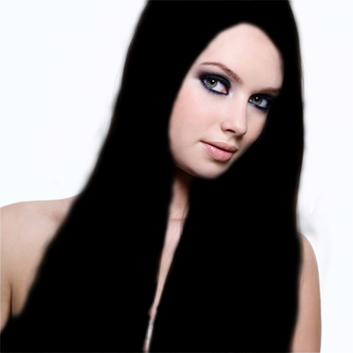

Now open **Actions** by clicking **Left click**.

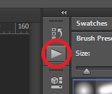

Select the hair color that you wish and click **Play button**.

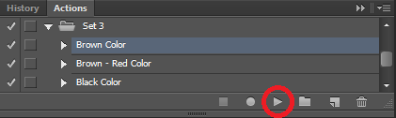

That's it. You have great natural color effect that you chosen. Thanks for buying. ☺

If you want to choose some other color, you don’t have to close your image, and then open it again and select hair again, just delete all layers above **Layer 1**. And then select **Layer 1** and play action of some other color that you like.

Here is the example. Here I got only one layer above **Layer 1**, sometimes you will have more than one, anyway delete all layers above **Layer 1**. Simply by selecting layer and then clicking **Right click** on it, and choose **Delete Layer**.

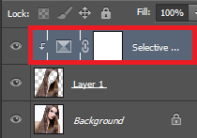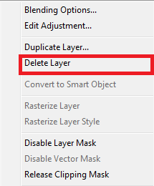

Tip:

You can combine a few colors and make your own. For example, you can color your hair to **Red**, and then play **Darker Color action** and get **Darker Red Color**. To do this, just after you color your hair to one color, **hold CTRL** and select all layers except **Background**, and click **Right click** and choose **Merge Layers**.

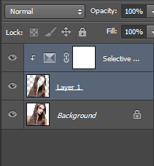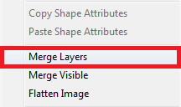

After that go to **Layer** -> **New** -> **Layer…** and play action of color that you wish to mix with previous.